TASK 2 – TICKET BOOKING SYSTEM

(Select, Where, Between, AND, LIKE)

1. Write a SQL query to insert at least 10 sample records into each table.

Venu Table:

INSERT INTO Venu VALUES(101, 'Riverside Event Hall', 'Austin');

INSERT INTO Venu VALUES(102, 'Grand Plaza Convention Center', 'Springfield');

INSERT INTO Venu VALUES(103, 'Skyline Conference Arena', 'Denver');

INSERT INTO Venu(venue_id, venue_name, address) VALUES(104, 'Harborview Banquet Hall', 'San Francisco'),

-> (105, 'Crystal Palace Venue', 'Orlando'),

-> (106, 'Emerald Garden Pavilion', 'Portland');

mysql> INSERT INTO Venu(venue_id, venue_name, address) VALUES(107, 'The Summit Event Center', 'Seattle'),

-> (108, 'Lakeside Meeting Hall', 'Minneapolis'),

-> (109, 'The Regency Ballroom', 'Atlanta'),

-> (110, 'Oakwood Banquet and Conference Center', 'Nashville');

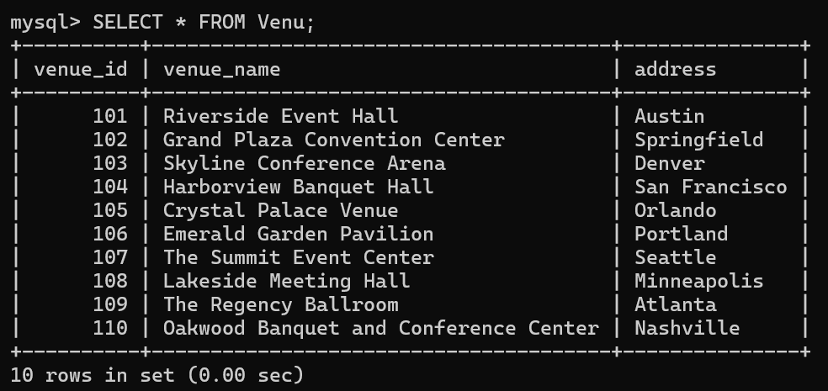

Event Table:

mysql> INSERT INTO Event (event_id, event_name, event_date, event_time, venue_id, total_seats, available_seats, ticket_price, event_type, Booking_id)

-> VALUES

-> (201, 'Jazz Night', '2024-10-10', '19:00:00', 101, 500, 480, 75, 'Concert', NULL),

-> (202, 'Championship Football', '2024-11-12', '15:00:00', 102, 30000, 28000, 100, 'Sports', NULL),

-> (203, 'Rock Concert', '2024-12-05', '20:30:00', 103, 1500, 1200, 150, 'Concert', NULL),

-> (204, 'Stand-up Comedy', '2024-09-30', '18:00:00', 104, 600, 550, 50, 'Concert', NULL),

-> (205, 'Basketball Finals', '2024-10-20', '17:00:00', 105, 18000, 17000, 120, 'Sports', NULL),

-> (206, 'New Release Movie', '2024-11-02', '21:00:00', 106, 300, 200, 15, 'Movie', NULL),

-> (207, 'Music Festival', '2024-09-25', '16:00:00', 107, 2000, 1900, 200, 'Concert', NULL),

-> (208, 'Local Soccer Match', '2024-10-15', '14:30:00', 108, 25000, 24000, 80, 'Sports', NULL),

-> (209, 'Movie Premiere', '2024-12-01', '19:30:00', 109, 400, 350, 25, 'Movie', NULL),

-> (210, 'Open-Air Concert', '2024-10-30', '18:30:00', 110, 800, 600, 90, 'Concert', NULL);

Query OK, 10 rows affected (0.03 sec)

Records: 10 Duplicates: 0 Warnings: 0

Customers Table:

mysql> INSERT INTO Customers (customer_id, customer_name, email, phone_number, Booking_id)

-> VALUES

-> (1, 'John Doe', 'john.doe@example.com', '123-456-7890', NULL),

-> (2, 'Jane Smith', 'jane.smith@example.com', '234-567-8901', NULL),

-> (3, 'Michael Johnson', 'michael.johnson@example.com', '345-678-9012', NULL),

-> (4, 'Emily Davis', 'emily.davis@example.com', '456-789-0123', NULL),

-> (5, 'Robert Brown', 'robert.brown@example.com', '567-890-1234', NULL),

-> (6, 'Sophia Anderson', 'sophia.anderson@example.com', '678-901-2345', NULL),

-> (7, 'David Martinez', 'david.martinez@example.com', '789-012-3456', NULL),

-> (8, 'Emma Wilson', 'emma.wilson@example.com', '890-123-4567', NULL),

-> (9, 'James Taylor', 'james.taylor@example.com', '901-234-5678', NULL),

-> (10, 'Linda Moore', 'linda.moore@example.com', '012-345-6789', NULL);

Query OK, 10 rows affected (0.02 sec)

Records: 10 Duplicates: 0 Warnings: 0

Booking Table:

mysql> INSERT INTO Booking (booking_id, customer_id, event_id, num_tickets, total_cost, booking_date)

-> VALUES

-> (301, 1, 201, 2, 150, '2024-09-01'),

-> (302, 2, 202, 4, 400, '2024-09-02'),

-> (303, 3, 203, 3, 450, '2024-09-03'),

-> (304, 4, 204, 1, 50, '2024-09-04'),

-> (305, 5, 205, 5, 600, '2024-09-05'),

-> (306, 6, 206, 2, 30, '2024-09-06'),

-> (307, 7, 207, 4, 800, '2024-09-07'),

-> (308, 8, 208, 2, 160, '2024-09-08'),

-> (309, 9, 209, 1, 25, '2024-09-09'),

-> (310, 10, 210, 3, 270, '2024-09-10');

Query OK, 10 rows affected (0.01 sec)

Records: 10 Duplicates: 0 Warnings: 0

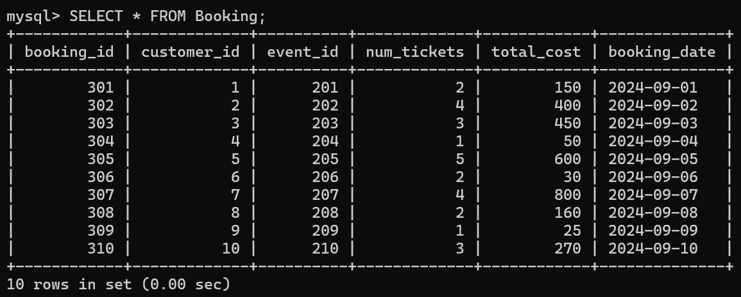

Update Event table:

UPDATE Event SET Booking_id = 301 WHERE event_id = 201;

UPDATE Event SET Booking_id = 302 WHERE event_id = 202;

UPDATE Event SET Booking_id = 303 WHERE event_id = 203;

UPDATE Event SET Booking_id = 304 WHERE event_id = 204;

UPDATE Event SET Booking_id = 305 WHERE event_id = 205;

UPDATE Event SET Booking_id = 306 WHERE event_id = 206;

UPDATE Event SET Booking_id = 307 WHERE event_id = 207;

UPDATE Event SET Booking_id = 308 WHERE event_id = 208;

UPDATE Event SET Booking_id = 309 WHERE event_id = 209;

UPDATE Event SET Booking_id = 310 WHERE event_id = 210;

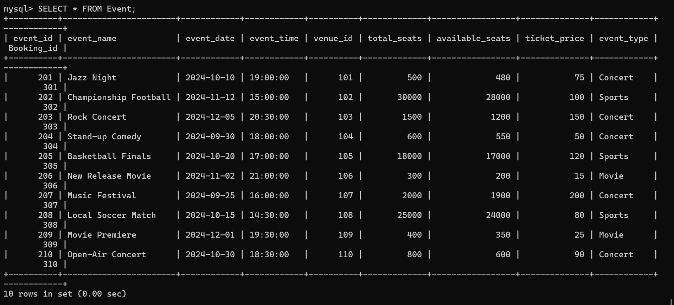

Update Customers Table:

UPDATE Customers SET Booking_id = 301 WHERE customer_id = 1;

UPDATE Customers SET Booking_id = 302 WHERE customer_id = 2;

UPDATE Customers SET Booking_id = 303 WHERE customer_id = 3;

UPDATE Customers SET Booking_id = 304 WHERE customer_id = 4;

UPDATE Customers SET Booking_id = 305 WHERE customer_id = 5;

UPDATE Customers SET Booking_id = 306 WHERE customer_id = 6;

UPDATE Customers SET Booking_id = 307 WHERE customer_id = 7;

UPDATE Customers SET Booking_id = 308 WHERE customer_id = 8;

UPDATE Customers SET Booking_id = 309 WHERE customer_id = 9;

UPDATE Customers SET Booking_id = 310 WHERE customer_id = 10;

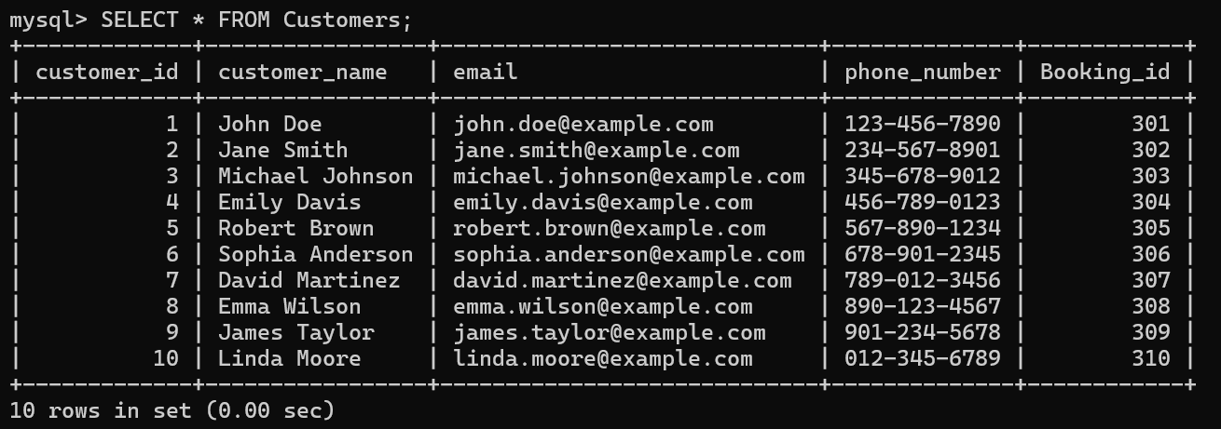

1. Write a SQL query to list all Events.

mysql> SELECT * FROM Event;



1. Write a SQL query to select events with available tickets.

mysql> SELECT event_id, event_name, available_seats FROM Event;

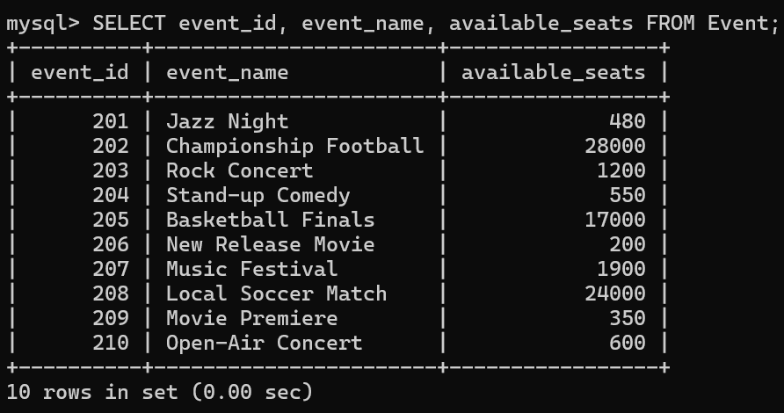

1. Write a SQL query to select events name partial match with ‘cup’.

SELECT EVENT_NAME FROM EVENT WHERE EVENT_NAME LIKE '%CUP%';

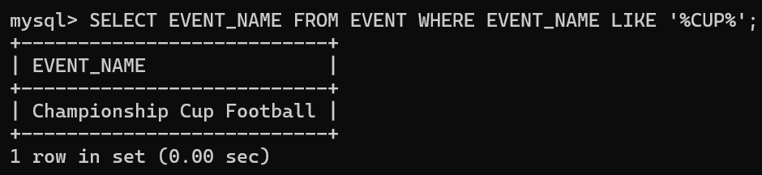

1. Write a SQL query to select events with ticket price range is between 1000 to 2500.

mysql> SELECT event_id, event_name, ticket_price FROM Event WHERE ticket_price BETWEEN 1000 AND 2500;

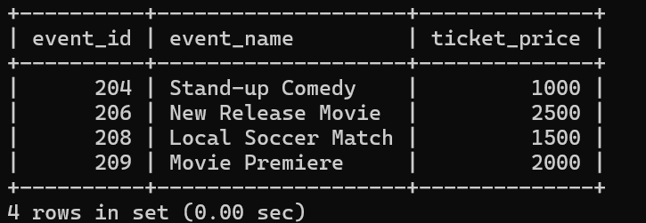

1. Write a SQL query to retrieve events with dates falling within a specific range.

mysql> SELECT event_id, event_name, event_date from Event WHERE event_date BETWEEN '2024-10-01' AND '2024-10-31';

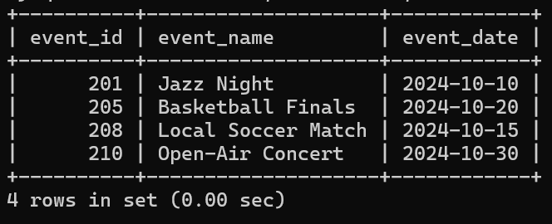

1. Write a SQL query to retrieve events with available tickets that also have "Concert" in their name.

mysql> SELECT event_id, event_name, available_seats, event_type FROM Event WHERE event_name like '%concert';

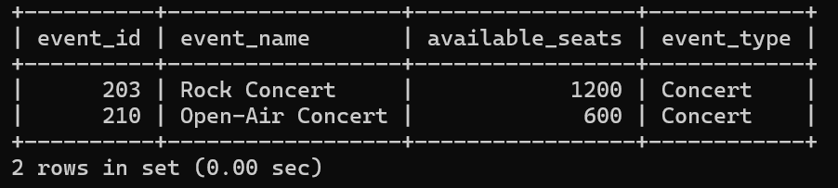

1. Write a SQL query to retrieve users in batches of 5, starting from the 6th user.

mysql> SELECT * FROM Customers WHERE customer_id BETWEEN 6 AND 10;

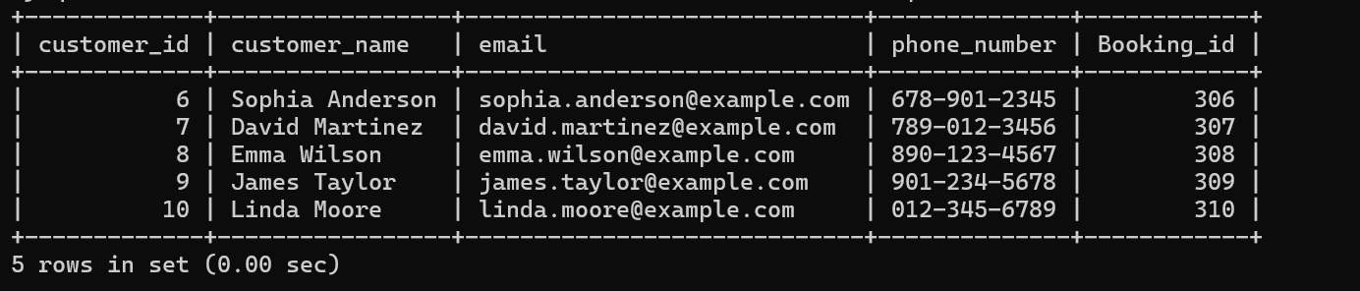

1. Write a SQL query to retrieve bookings details contains booked no of ticket more than 4.

mysql> SELECT * FROM Booking WHERE num_tickets > 4;

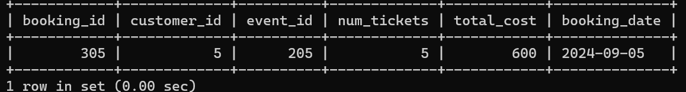

1. Write a SQL query to retrieve customer information whose phone number end with ‘000’

mysql> SELECT * FROM Customers WHERE phone_number LIKE '%000';

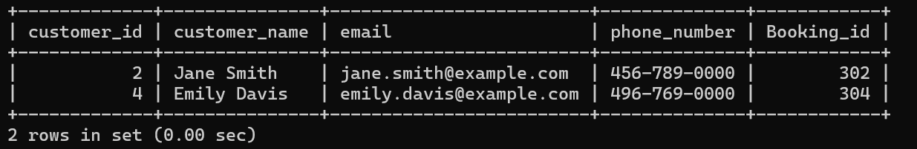

1. Write a SQL query to retrieve the events in order whose seat capacity more than 15000.

mysql> SELECT * FROM Event WHERE total_seats > 15000;

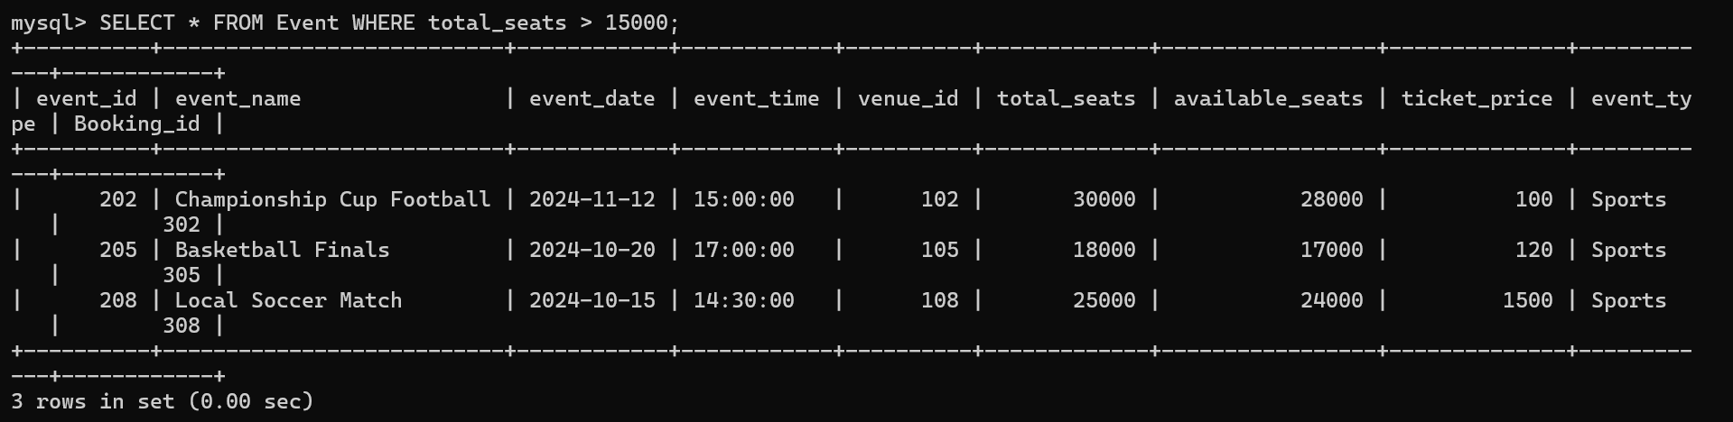

1. Write a SQL query to select events name not start with ‘x’, ‘y’, ‘z’

mysql> SELECT event_name from Event WHERE event_name NOT LIKE 'x%' AND event_name NOT LIKE 'y%' AND event_name NOT LIKE 'z%';

